Part 2

Creating DataFrame

Creating a DataFrame from an RDD

Create a DataFrame from the following RDD, then show the DataFrame’s schema and content:
list = [("Finance",10),("Marketing",20),("Sales",30),("IT",40)]
rdd = sc.parallelize(list)
df = rdd.toDF()
df.printSchema()
df.show()
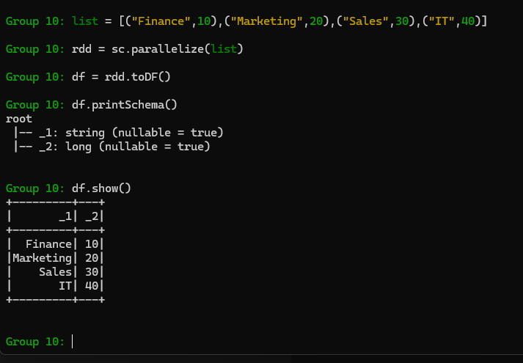

Create a DataFrame with column names from the following RDD, then show the DataFrame’s schema and content:
list = [("Finance",10),("Marketing",20),("Sales",30),("IT",40)]
rdd = sc.parallelize(list)
columns = ["dept_name","dept_id"]
df = rdd.toDF(columns)
df.printSchema()
df.show()
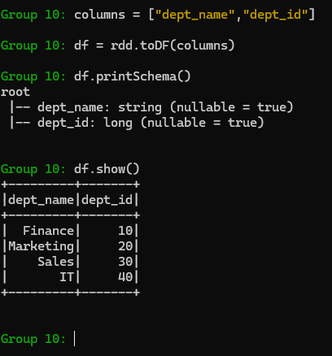

Create a DataFrame with StructType schema from the following RDD, then show the DataFrame’s schema and content:
from pyspark.sql.types import StructType,StructField, StringType, LongType
list = [("Finance",10),("Marketing",20),("Sales",30),("IT",40)]
rdd = sc.parallelize(list)
schema = StructType([
StructField('dept_name', StringType(), True),
StructField('dept_id', LongType(), True)
])
df = spark.createDataFrame(rdd, schema)
df.printSchema()
df.show(truncate=False)
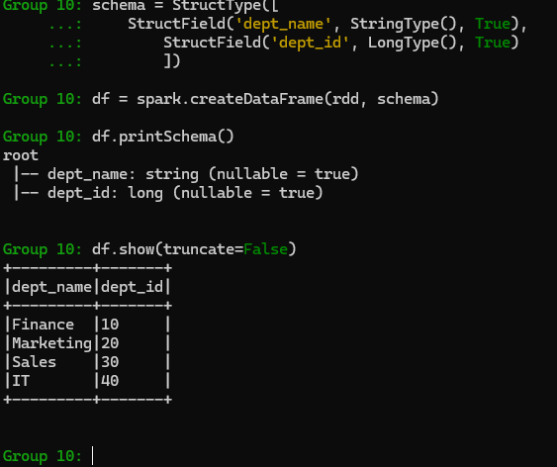

Creating a DataFrame from a LIST

Creating a DataFrame with column names from the following list:
list = [('James','','Smith','1991-04-01','M',3000),
('Michael','Rose','','2000-05-19','M',4000),
('Robert','','Williams','1978-09-05','M',4000),
('Maria','Anne','Jones','1967-12-01','F',4000),
('Jen','Mary','Brown','1980-02-17','F',-1)
]
columns = ["firstname","middlename","lastname","dob","gender","salary"]
df = spark.createDataFrame(list, columns)
df.printSchema()
df.show(truncate=False)
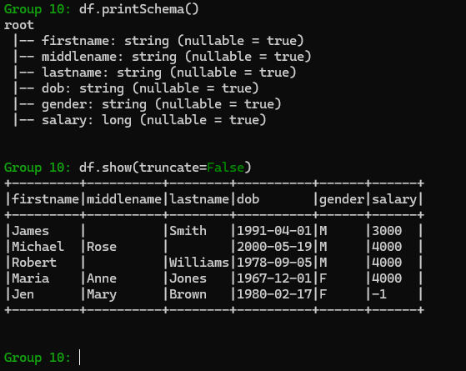

Creating a DataFrame with StructType schema from the following list:
from pyspark.sql.types import StructType,StructField, StringType, IntegerType
schema = StructType([ \
StructField("firstname", StringType(),True), \
StructField("middlename", StringType(),True), \
StructField("lastname", StringType(),True), \
StructField("dob", StringType(), True), \
StructField("gender", StringType(), True), \
StructField("salary", IntegerType(), True) \
])
list = [('James','','Smith','1991-04-01','M',3000),
('Michael','Rose','','2000-05-19','M',4000),
('Robert','','Williams','1978-09-05','M',4000),
('Maria','Anne','Jones','1967-12-01','F',4000),
('Jen','Mary','Brown','1980-02-17','F',-1)
]
df = spark.createDataFrame(list, schema)
df.printSchema()
df.show(truncate=False)
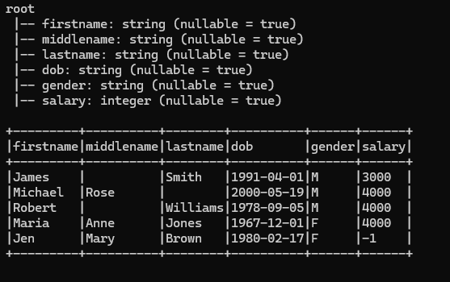

Creating a DataFrame from a CSV file

Creating a DataFrame from a CSV file
df = spark.read.csv("/data/emp.csv")
df.printSchema()
df.show()
Or
df = spark.read.format("csv").load("/data/emp.csv")
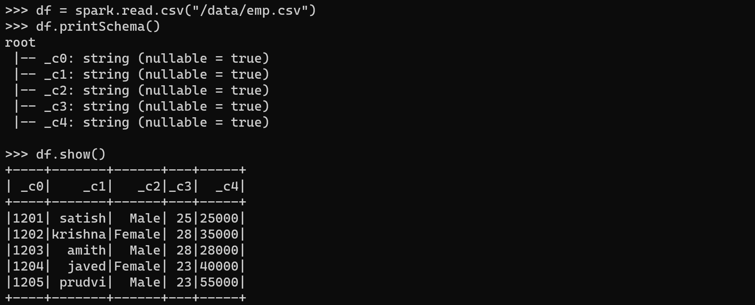

Read Multiple CSV Files
df = spark.read.csv(["/data/csv/file1.csv","/data/csv/file2.csv","/data/csv/file3.csv"])
df.show()
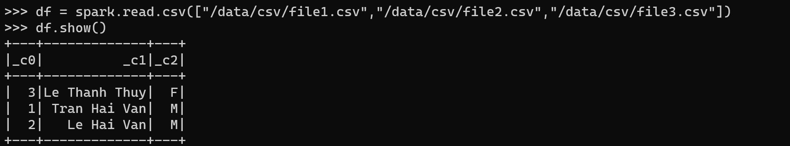

Read all CSV Files from a Directory
df = spark.read.csv("/data/csv/")
df.show(truncate=False)
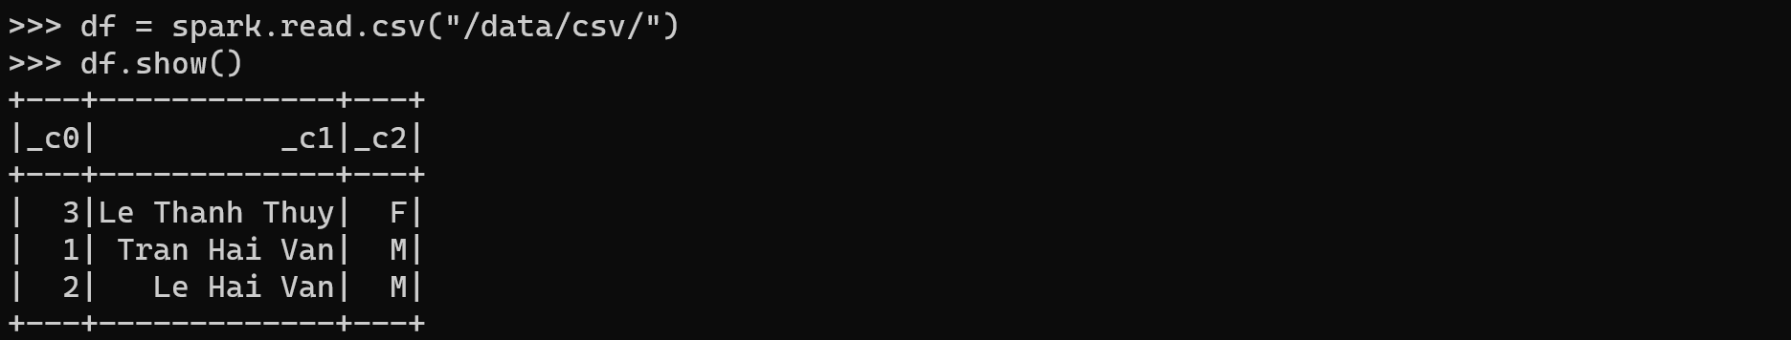

Read a CSV file with options:
Read a CSV file with header:
df = spark.read.option("header",True).csv("/data/emp.csvh")
df.printSchema()
df.show()
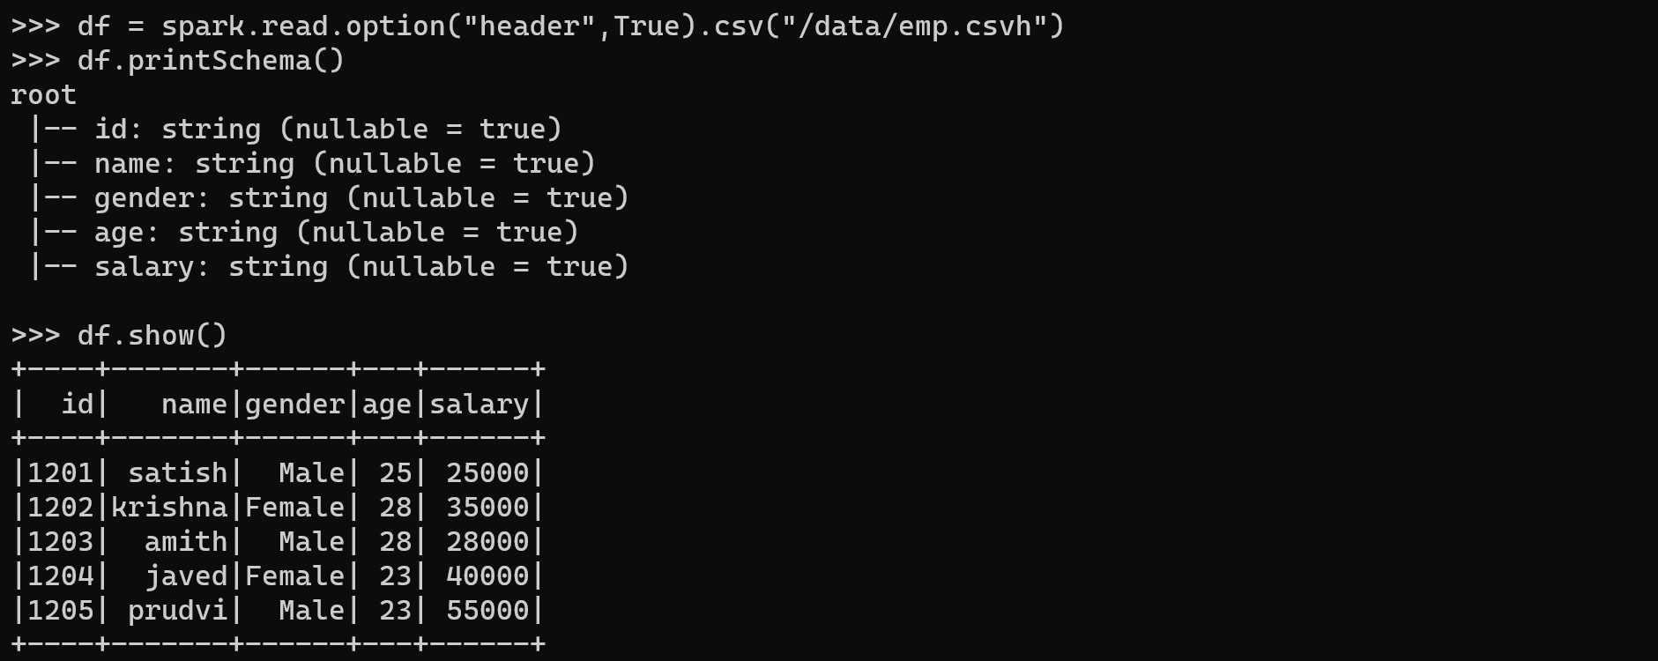
Read a CSV file with more options:
df = spark.read.options(header='True', inferSchema='True', delimiter=',') \
.csv("/data/emp.csvh")
df.printSchema()
df.show()
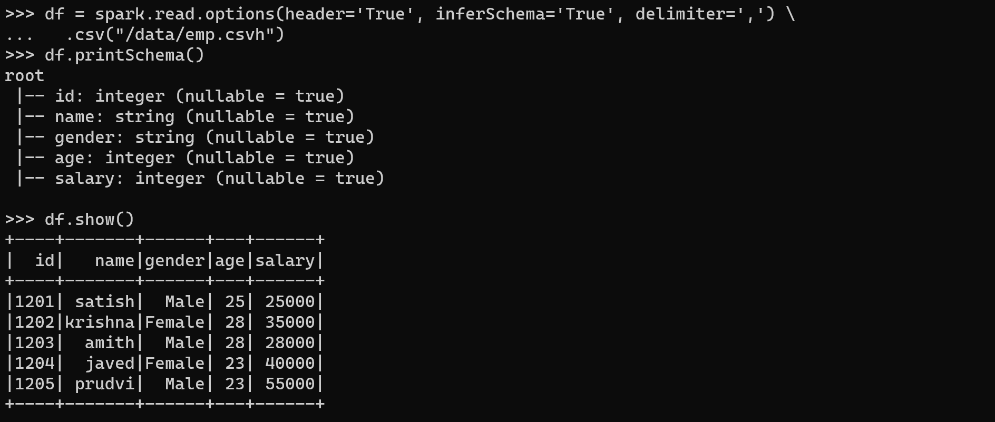

Reading CSV files with a user-specified custom schema

Reading CSV file without header
# Imports
from pyspark.sql.types import StructType,StructField, StringType, IntegerType, LongType
# Using custom schema
schema = StructType() \
.add("id",IntegerType(),True) \
.add("name",StringType(),True) \
.add("gender", StringType (),True) \
.add("age", IntegerType(),True) \
.add("salary", LongType(),True)
# Creating a dataframe from a csv file without header
df = spark.read.format("csv") \
.option("header", False) \
.schema(schema) \
.load("/data/emp.csv")
df.printSchema()
df.show()
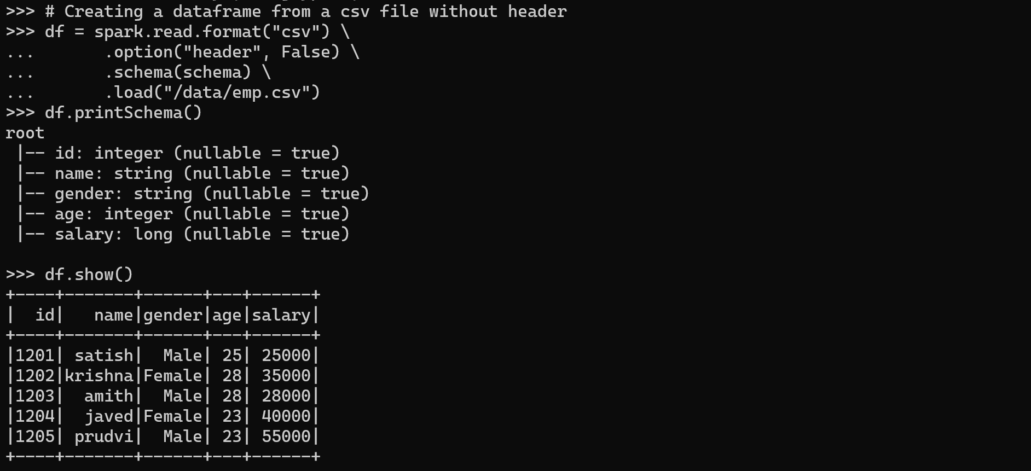

Reading CSV file with the header
df = spark.read.format("csv") \
.option("header", True) \
.schema(schema) \
.load("/data/emp.csvh")
df.printSchema()
df.show()
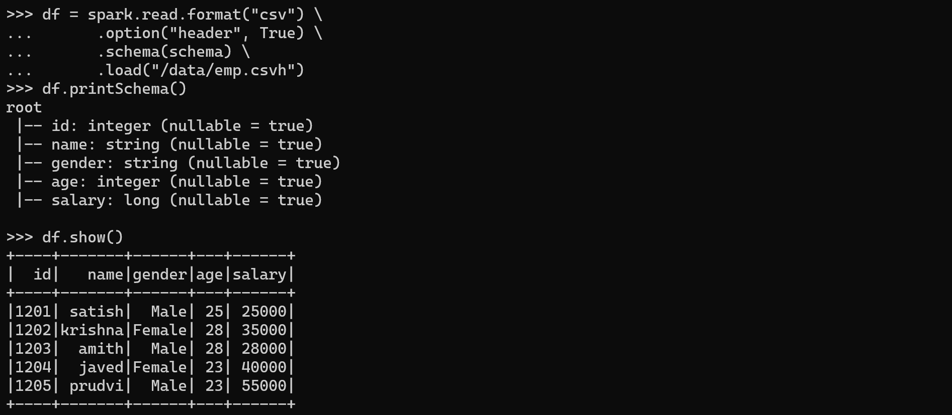

Reading CSV file with a complex schema
# Imports
from pyspark.sql.types import StructType,StructField, StringType, IntegerType
from pyspark.sql.types import ArrayType, DoubleType, BooleanType

# Using custom schema
schema = StructType() \
.add("RecordNumber",IntegerType(),True) \
.add("Zipcode",IntegerType(),True) \
.add("ZipCodeType",StringType(),True) \
.add("City",StringType(),True) \
.add("State",StringType(),True) \
.add("LocationType",StringType(),True) \
.add("Lat",DoubleType(),True) \
.add("Long",DoubleType(),True) \
.add("Xaxis",IntegerType(),True) \
.add("Yaxis",DoubleType(),True) \
.add("Zaxis",DoubleType(),True) \
.add("WorldRegion",StringType(),True) \
.add("Country",StringType(),True) \
.add("LocationText",StringType(),True) \
.add("Location",StringType(),True) \
.add("Decommisioned",BooleanType(),True) \
.add("TaxReturnsFiled",StringType(),True) \
.add("EstimatedPopulation",IntegerType(),True) \
.add("TotalWages",IntegerType(),True) \
.add("Notes",StringType(),True)

df = spark.read.format("csv") \
.option("header", True) \
.schema(schema) \
.load("/data/zipcodes.csv")
df.show()
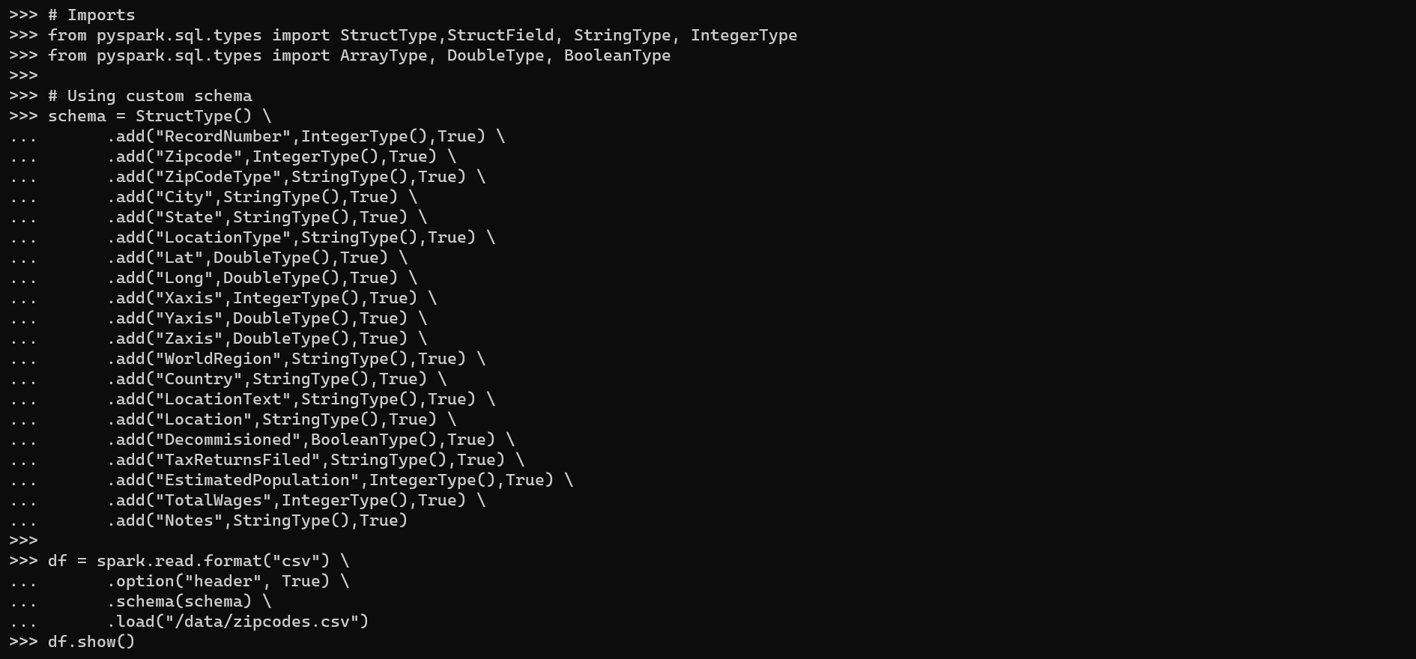

Creating a DataFrame from a JSON file

Reading a JSON file
df = spark.read.json("/data/emp.json")
df.printSchema()
df.show()
Or
df = spark.read.format("json").load("/data/emp.json")
df.printSchema()
df.show()
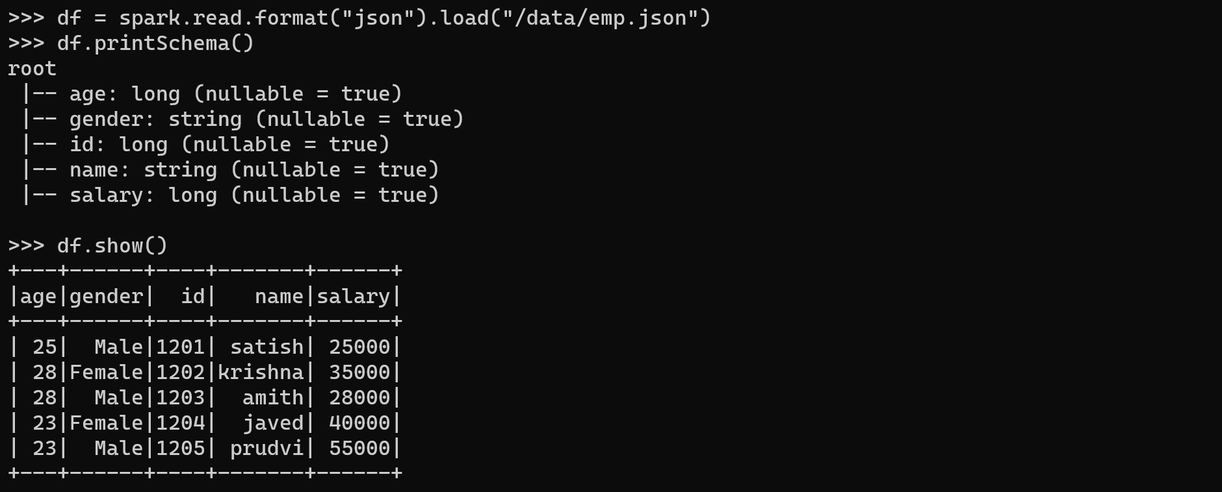

Reading JSON files with a custom schema
# Imports
from pyspark.sql.types import StructType,StructField, StringType, IntegerType, LongType
# Define custom schema
schema = StructType() \
.add("id",IntegerType(),True) \
.add("name",StringType(),True) \
.add("gender", StringType (),True) \
.add("age", IntegerType(),True) \
.add("salary", LongType(),True)
df = spark.read.format("json") \
.schema(schema) \
.load("/data/emp.json")
df.printSchema()
df.show()
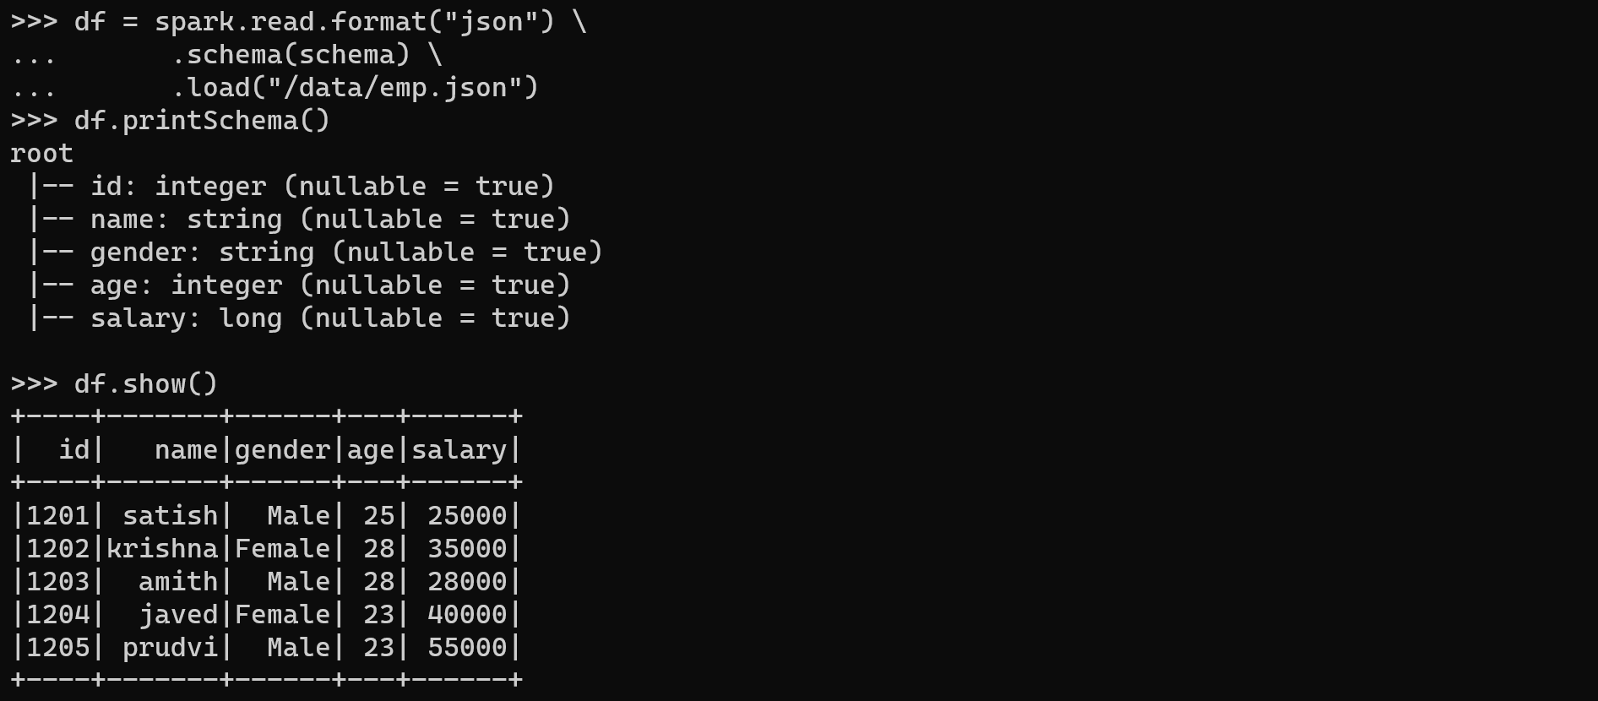

Writing DataFrame to Files

Writing DataFrame to CSV file

Without header
df.write \
.csv("/data/spark_output/emp1")
# cat data/spark_output/emp1/*
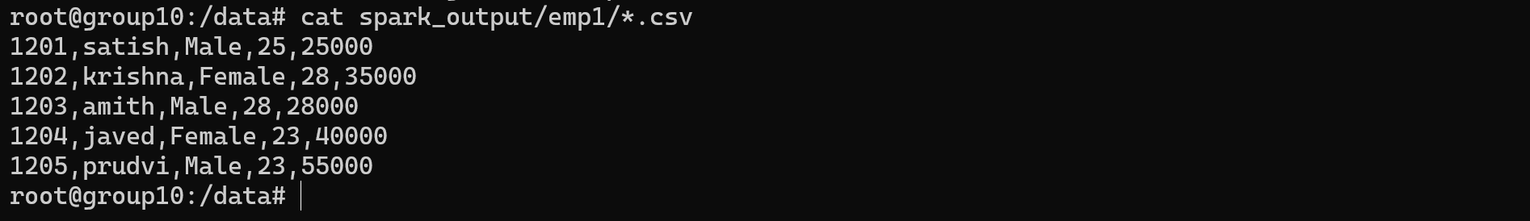

With header
df.write \
.option("header",True) \
.csv("/data/spark_output/emp2")
# cat data/spark_output/emp2/*
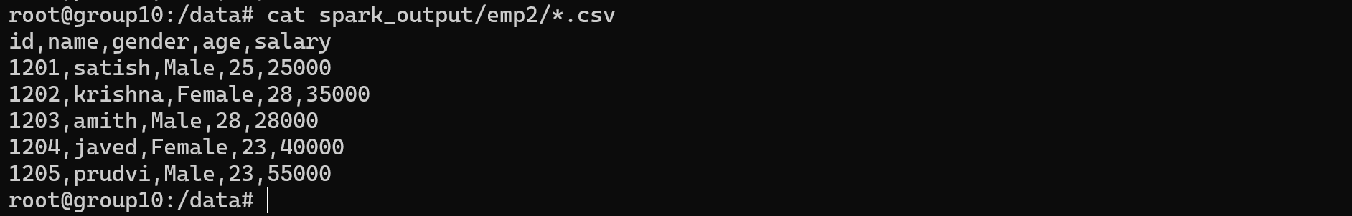

With header and delemiter
df.write \
.options(header="True",delimiter="\t") \
.csv("/data/spark_output/emp3")
# cat data/spark_output/emp3/*
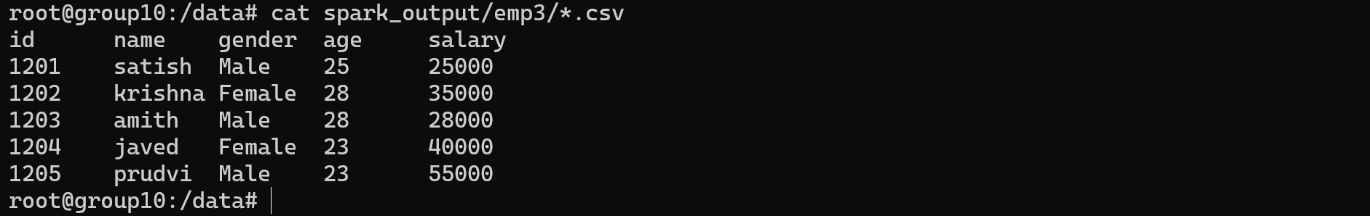

Write DataFrame to JSON file
df.write.json("/data/spark_output/emp4")
# cat data/spark_output/emp4/*
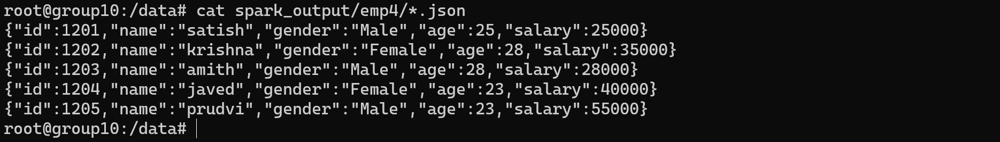

Basic Operations

Creating DataFrame
# Data
data = [("James","Smith","USA","CA"),
("Michael","Rose","USA","NY"),
("Robert","Williams","USA","CA"),
("Maria","Jones","USA","FL")
]
# Column names
columns = ["firstname","lastname","country","state"]
# Create DataFrame
df = spark.createDataFrame(data, columns)
df.show()
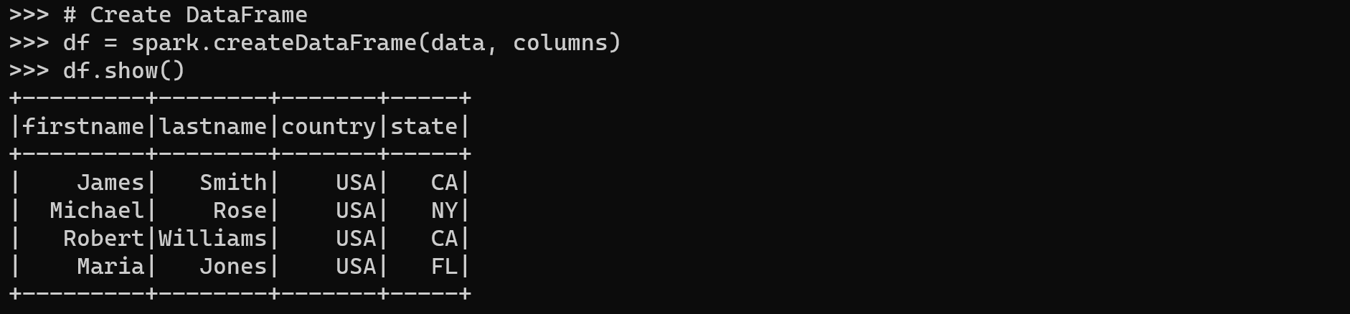

Select columns

Select some columns
Select columns by different ways:
df.select("firstname","lastname").show()
df.select(df.firstname,df.lastname).show()
df.select(df["firstname"],df["lastname"]).show()
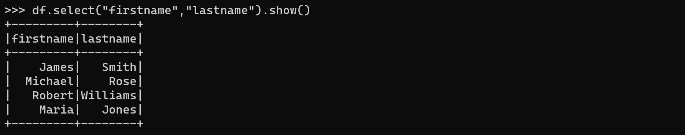
By using the col() function:
from pyspark.sql.functions import col
df.select(col("firstname"),col("lastname")).show()
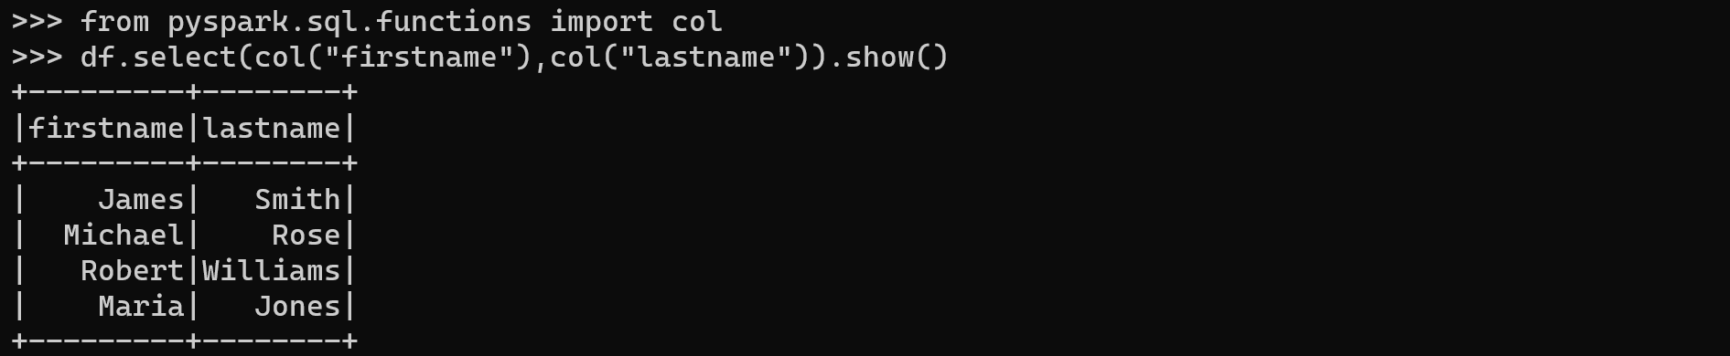

Select all columns
Use one of the following methods:
df.show()
df.select(*columns).show()
df.select("*").show()
df.select([col for col in df.columns]).show()
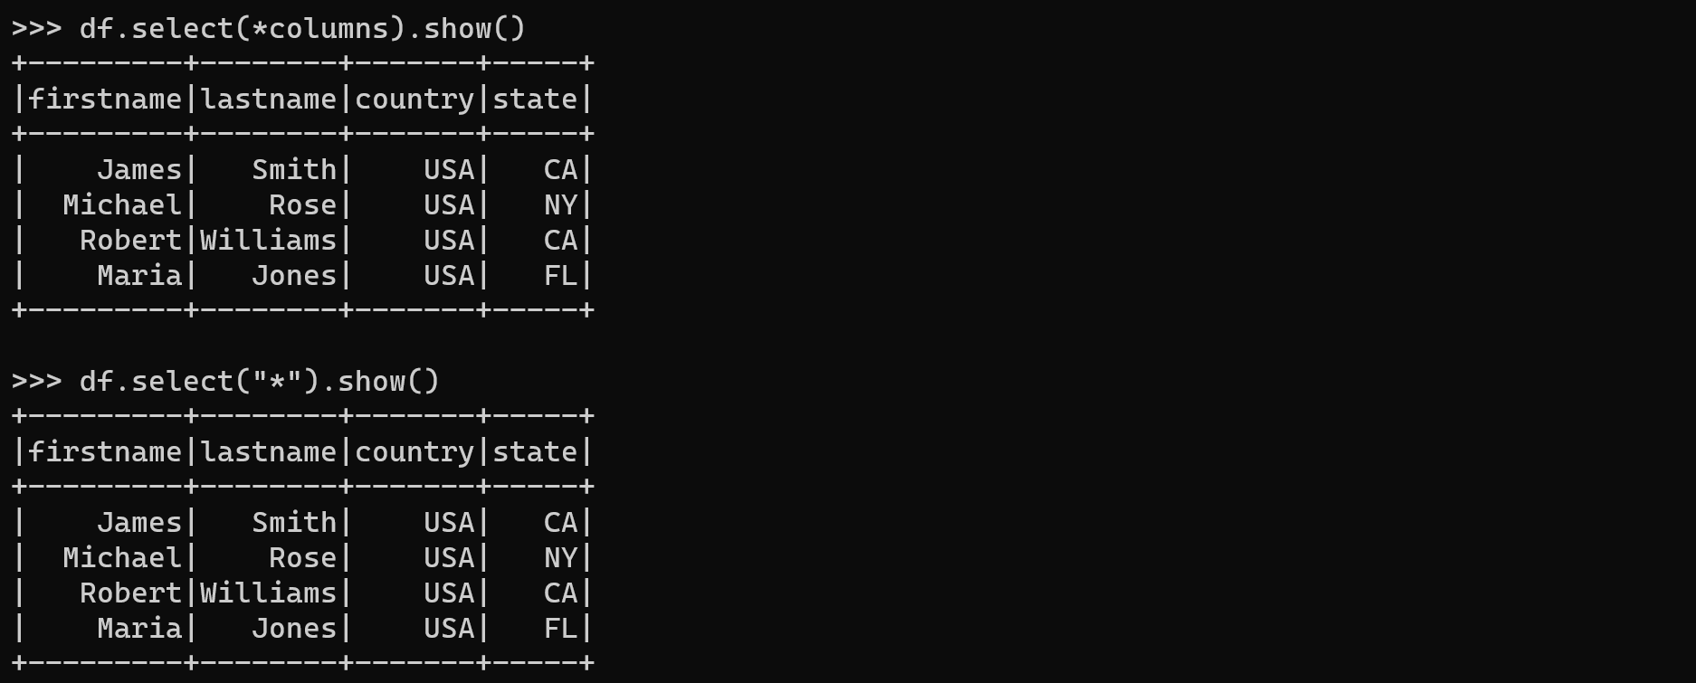

Select columns by Index
Selects the first 3 columns and the top 3 rows:
df.select(df.columns[:3]).show(3)
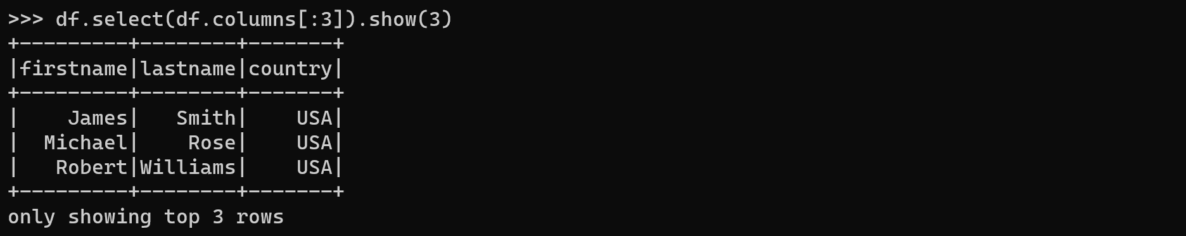
Selects columns 2 to 3 and the top 3 rows:
df.select(df.columns[2:4]).show(3)
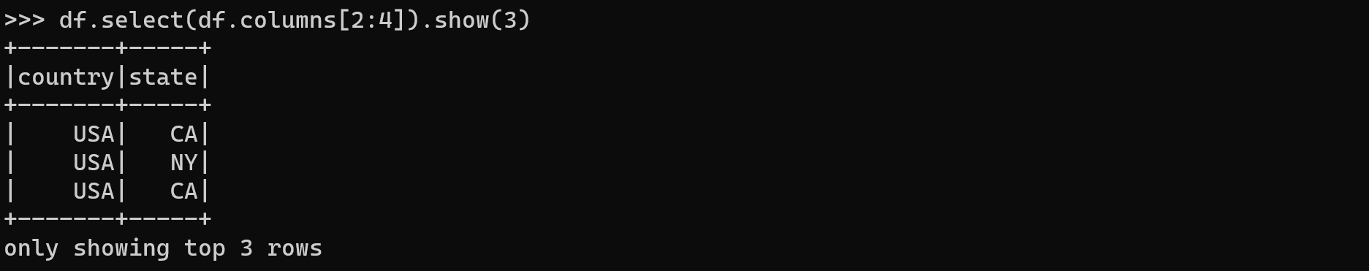

Select Nested Struct Columns from PySpark

Create DataFrame with nested columns
data = [
(("James",None,"Smith"),"OH","M"),
(("Anna","Rose",""),"NY","F"),
(("Julia","","Williams"),"OH","F"),
(("Maria","Anne","Jones"),"NY","M"),
(("Jen","Mary","Brown"),"NY","M"),
(("Mike","Mary","Williams"),"OH","M")
]
from pyspark.sql.types import StructType,StructField, StringType
schema = StructType([
StructField('name', StructType([
StructField('firstname', StringType(), True),
StructField('middlename', StringType(), True),
StructField('lastname', StringType(), True)
])),
StructField('state', StringType(), True),
StructField('gender', StringType(), True)
])
df = spark.createDataFrame(data, schema)
df.printSchema()
df.show(truncate=False)
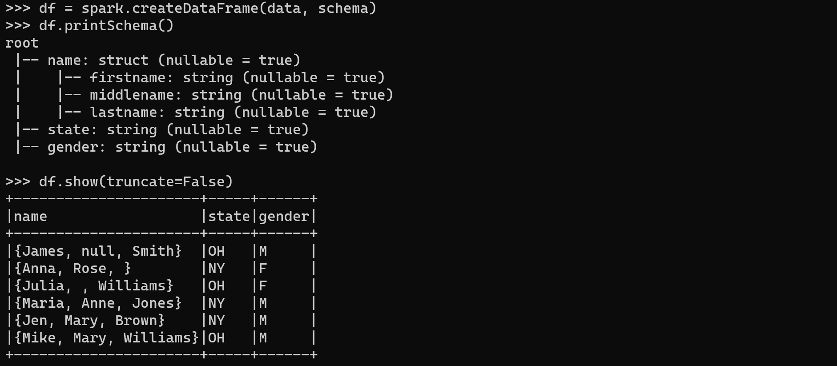

Select the struct column
Select the struct column:
df.select("name").show()
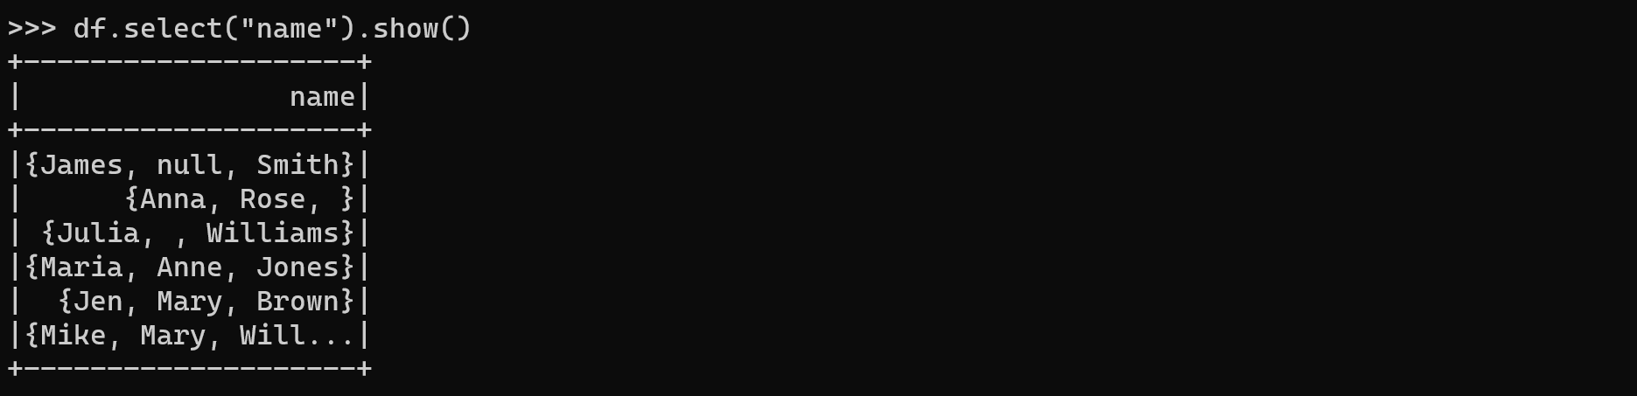
Select child columns:
df.select("name.firstname","name.lastname").show()
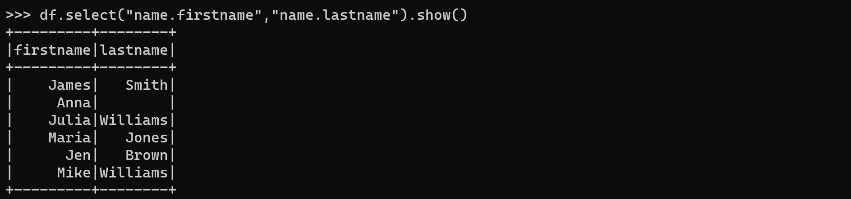
Select all child columns:
df.select("name.*","state").show()
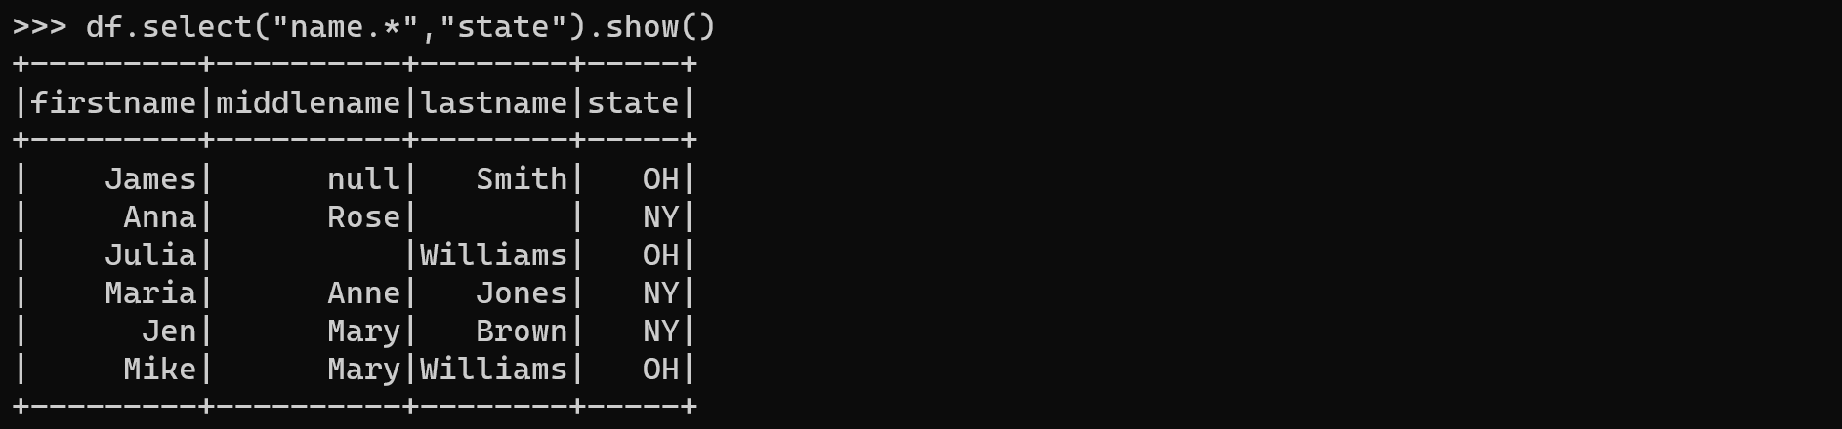

Rename columns
df = df.withColumnRenamed("name","fullname")
df.show()
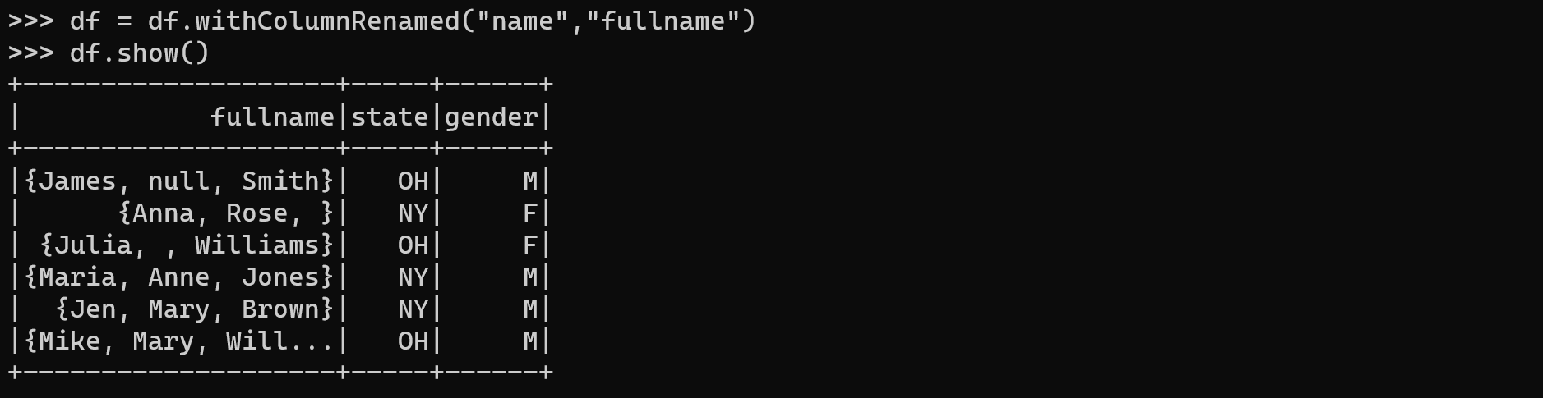

Adding/Updating columns

Syntax
df.withColumn(colName, col)

Updating columns
df.withColumn("age",df.age+1).show()
Or
from pyspark.sql.functions import col
df.withColumn("age", col("age")+1).show()

Adding columns
# Using the when function
from pyspark.sql.functions import when
df.withColumn("newgender",
when(df.gender == "M","Male") \
.when(df.gender == "F","Female") \
.otherwise(df.gender)) \
.show()
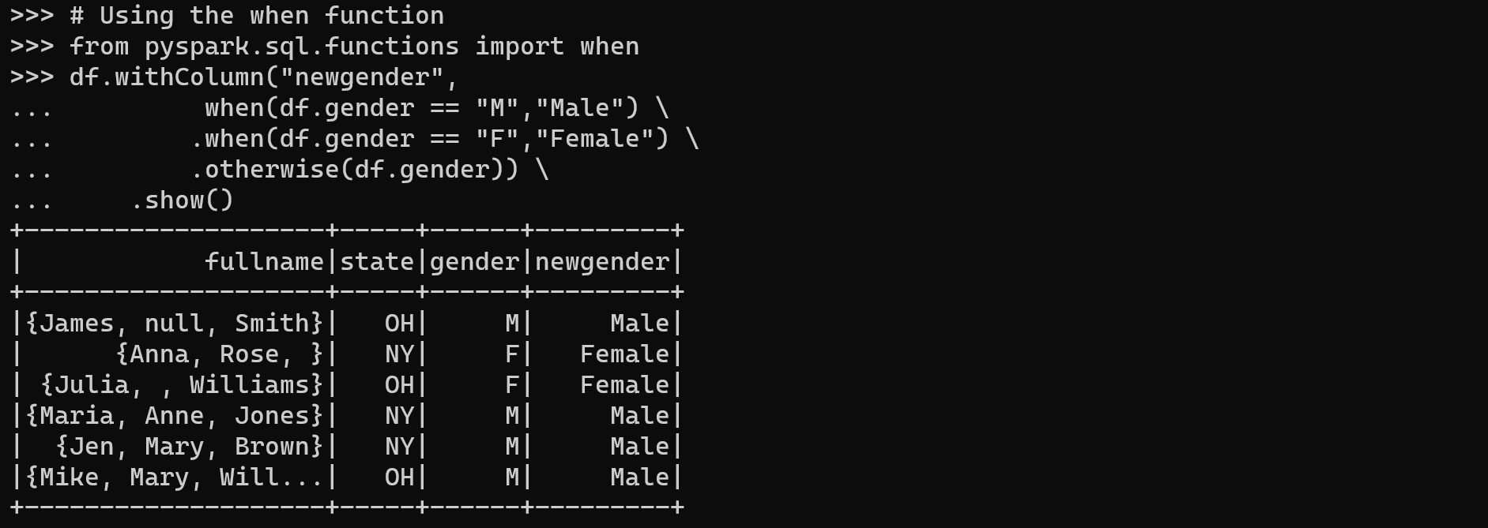
# Using constants
from pyspark.sql.functions import lit
df.withColumn("country",lit("USA")).show()
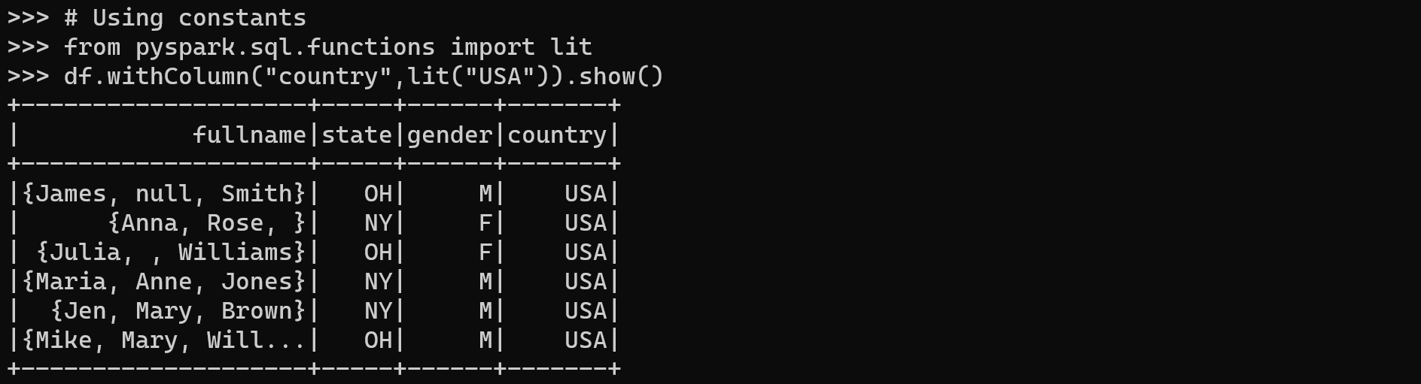

Updating columns’ types
df.printSchema()
df.withColumn("salary",df.salary.cast("String")).printSchema()

Drop columns
df.drop("state","gender").show()
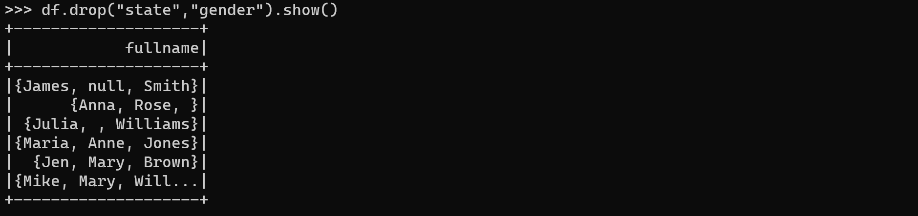

Filtering DataFrame

Syntax
df.filter(condition)
df.where(condition)
Note: The where() method is an alias for the filter() method.

Creating DataFrame
# Imports
from pyspark.sql.types import StructType,StructField
from pyspark.sql.types import StringType, IntegerType, ArrayType
# Create data
data = [
(("James","","Smith"),["Java","Scala","C++"],"OH","M"),
(("Anna","Rose",""),["Spark","Java","C++"],"NY","F"),
(("Julia","","Williams"),["CSharp","VB"],"OH","F"),
(("Maria","Anne","Jones"),["CSharp","VB"],"NY","M"),
(("Jen","Mary","Brown"),["CSharp","VB"],"NY","M"),
(("Mike","Mary","Williams"),["Python","VB"],"OH","M")
]
# Create schema
schema = StructType([
StructField('name', StructType([
StructField('firstname', StringType(), True),
StructField('middlename', StringType(), True),
StructField('lastname', StringType(), True)
])),
StructField('languages', ArrayType(StringType()), True),
StructField('state', StringType(), True),
StructField('gender', StringType(), True)
])
# Create dataframe
df = spark.createDataFrame(data, schema)
df.printSchema()
df.show(truncate=False)
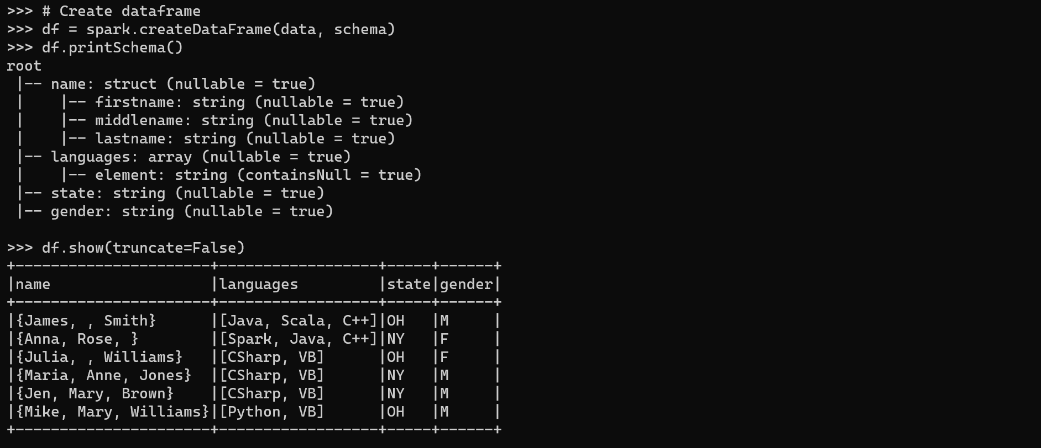

Using equal filter condition
df.filter(df.state == "OH").show(truncate=False)
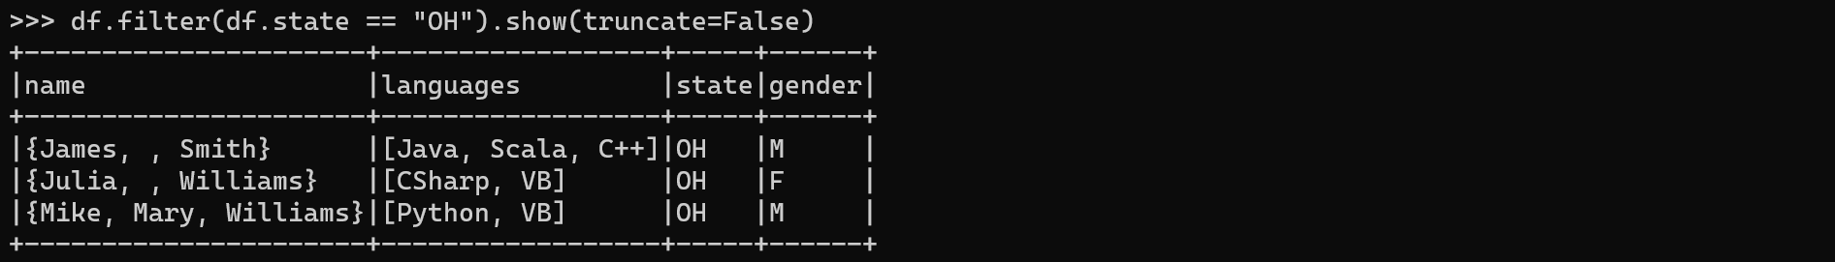
df.filter("state == 'OH'").show(truncate=False)
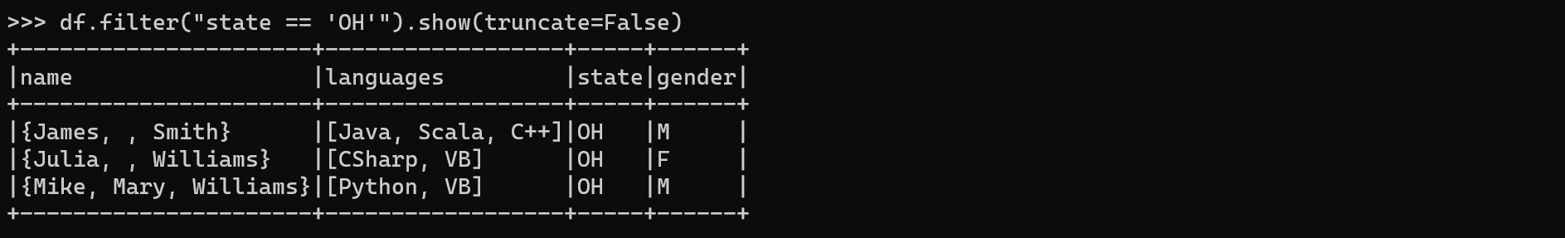

Using not equal filter condition
df.filter(df.state != "OH").show(truncate=False)
df.filter("state != 'OH'").show(truncate=False)
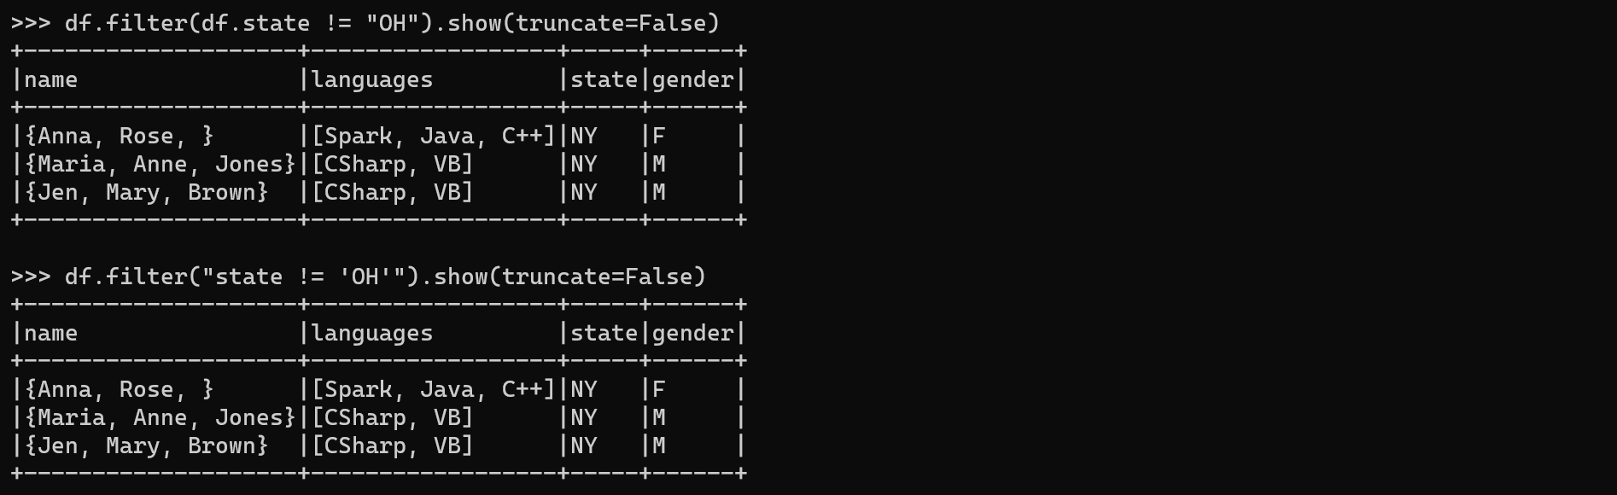

Filtering with Multiple Conditions
Combining conditions using logical operators like & (AND), | (OR), and ~ (NOT).
df.filter( (df.state == "OH") & (df.gender == "M") ) \
.show(truncate=False)
df.filter( (df.state == "OH") | (df.gender == "M") ) \
.show(truncate=False)
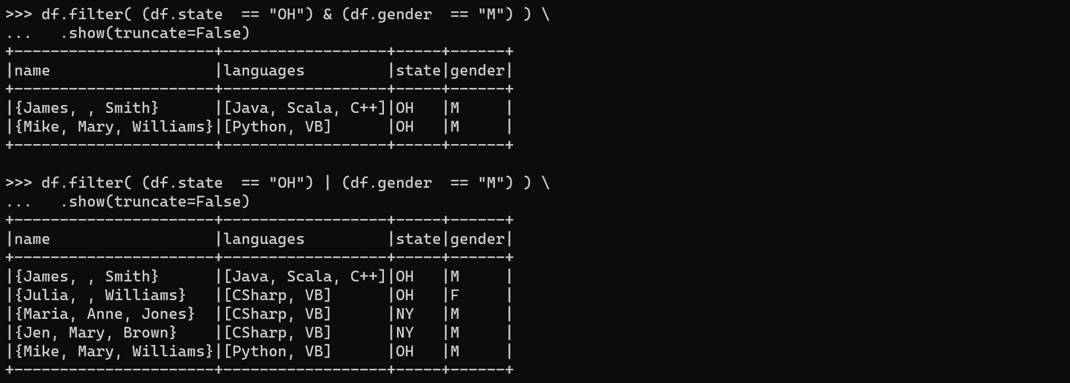

Filtering Based on List Values
list=["OH","CA","DE"]
df.filter(df.state.isin(list)).show()
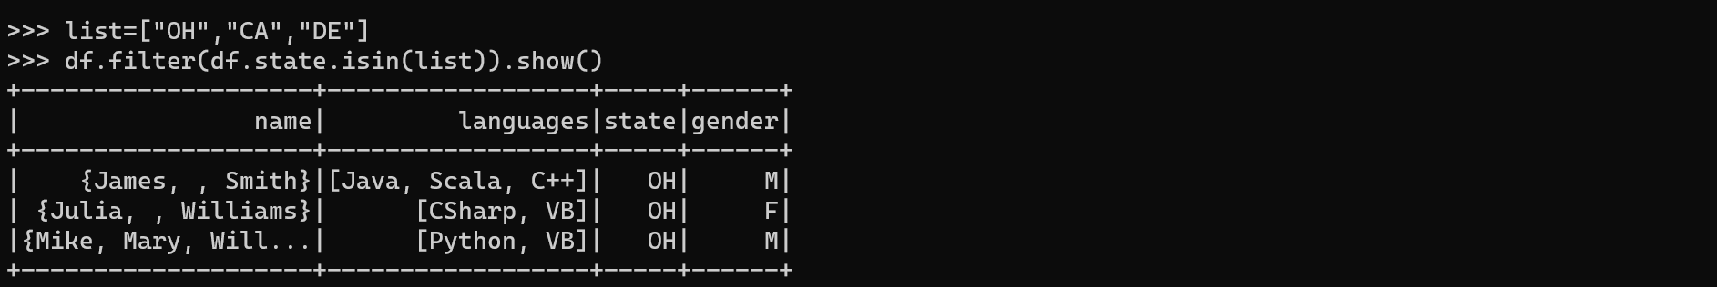

Filtering Based on String
Use startswith(), endswith() and contains() methods of Column class to select rows starts with, ends with, and contains a value.
df.filter(df.name.firstname.startswith("J")).show()
df.filter(df.name.firstname.endswith("a")).show()
df.filter(df.name.firstname.contains("e")).show()
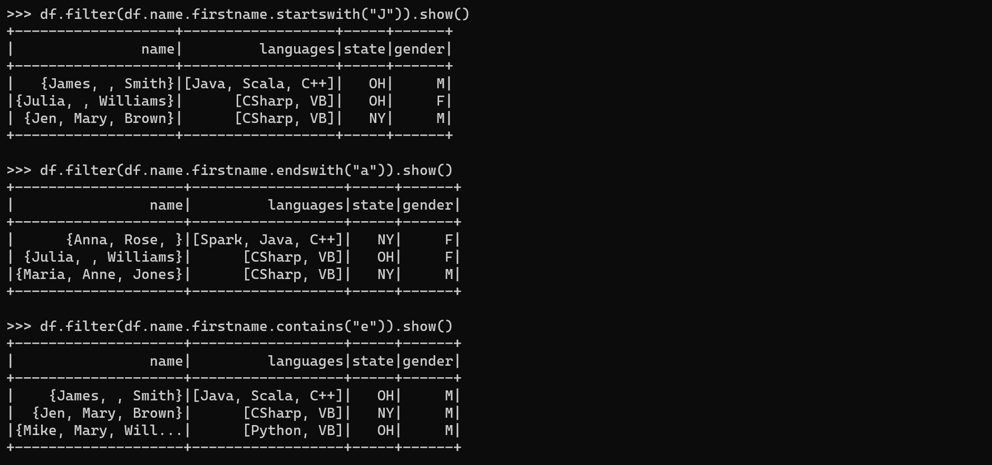

Filtering with Regular Expression
Use like() and rlike() (regex like, for case insensitive).
df.filter(df.name.firstname.like("%ia%")).show()
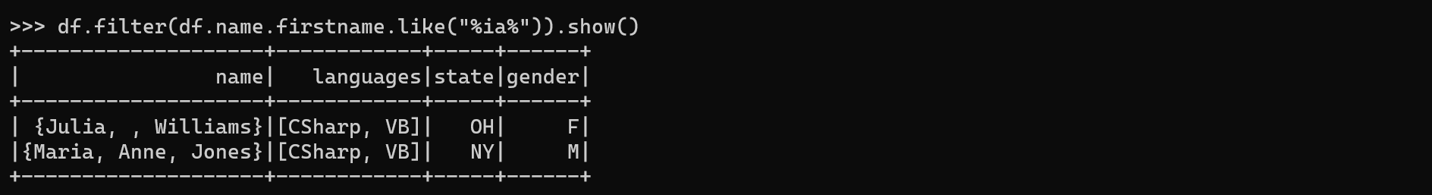

Filtering Array columns
from pyspark.sql.functions import array_contains
df.filter(array_contains(df.languages,"Java")).show()
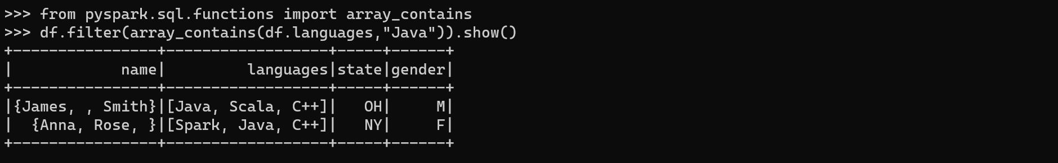

Redo exercise 2.4.3 using the IDE

Sorting DataFrame

Syntax
df.sort(*cols, **kwargs)
df.orderBy(*cols, **kwargs)
Note: orderBy() is just an alias for the sort() function

Creating DataFrame
data = [("James","Sales","NY",90000,34,10000), \
("Michael","Sales","NY",86000,56,20000), \
("Robert","Sales","CA",81000,30,23000), \
("Maria","Finance","CA",90000,24,23000), \
("Raman","Finance","CA",99000,40,24000), \
("Scott","Finance","NY",83000,36,19000), \
("Jen","Finance","NY",79000,53,15000), \
("Jeff","Marketing","CA",80000,25,18000), \
("Kumar","Marketing","NY",91000,50,21000) \
]
columns= ["employee_name","department","state","salary","age","bonus"]
df = spark.createDataFrame(data, columns)
df.printSchema()
df.show()
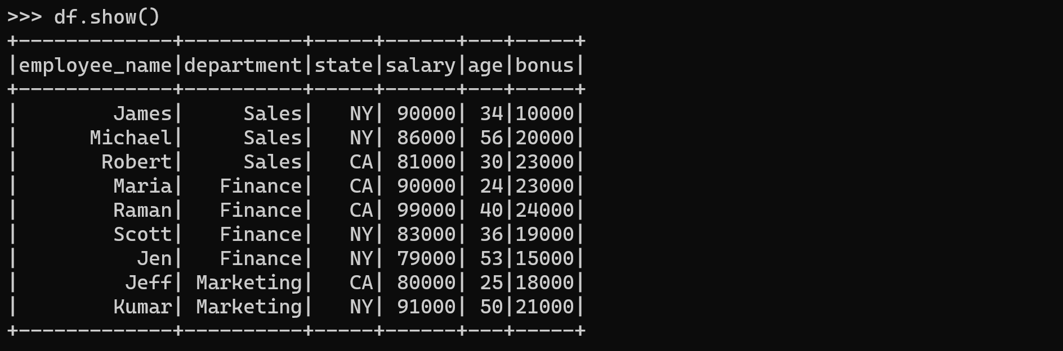

Simple sorting
df.sort("department","state").show()
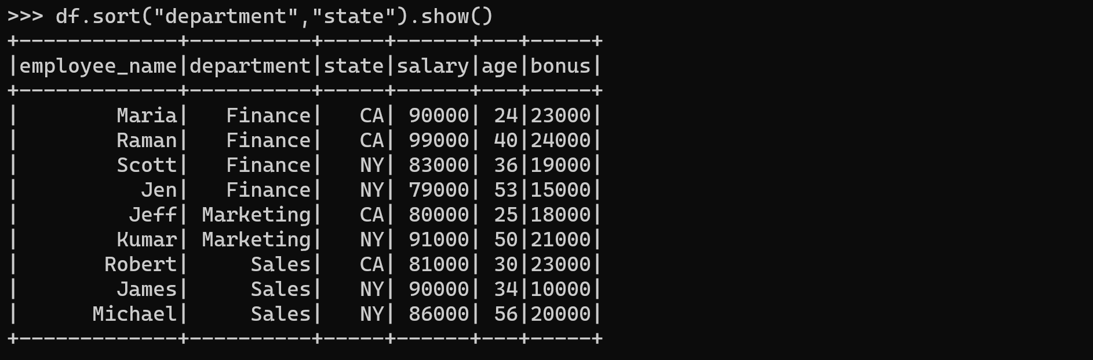

Sorting by Ascending (ASC)/ Descending (DESC)
df.sort(df.department.asc(),df.state.desc()).show()
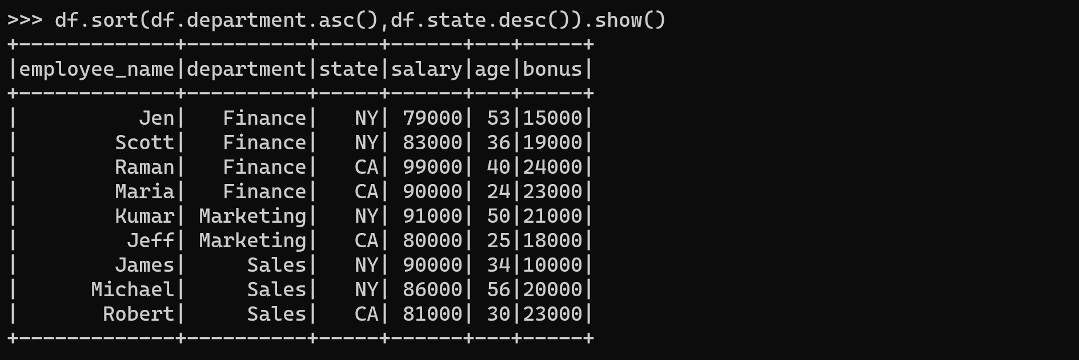

Redo exercise 2.5.4 using the IDE

Spark SQL

Creating DataFrame
Redo exercise 2.5.2 if your dataframe df is lost.

Create temporary tables
Create the temporary table EMP from the dataframe df.
df.createOrReplaceTempView("EMP")

Select data from temporary tables
Select all employees:
df = spark.sql(“select * from EMP")
df.printSchema()
df.show()
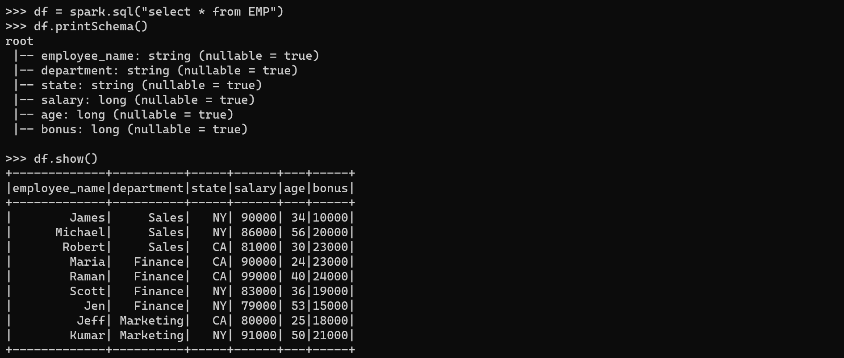
Count the number of employees:
spark.sql("select count(*) from EMP").show()
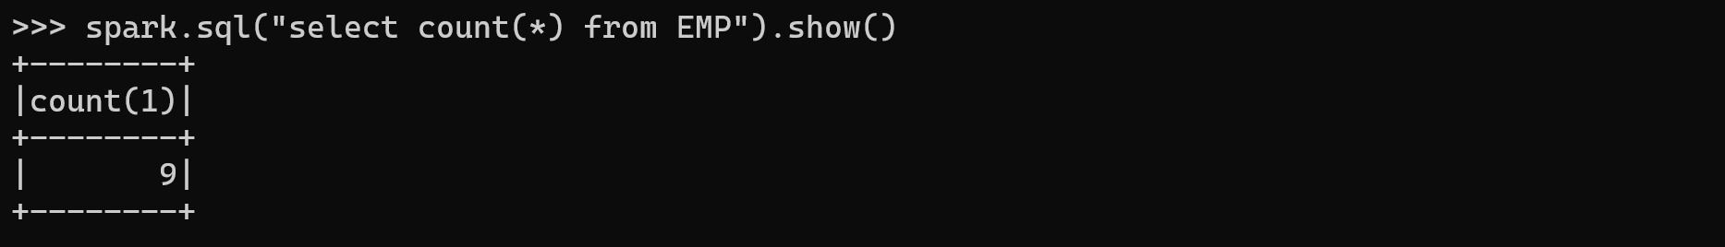
Calculate the total salary:
?? spark.sql("SELECT COUNT(*) AS employee_count FROM EMP").show()
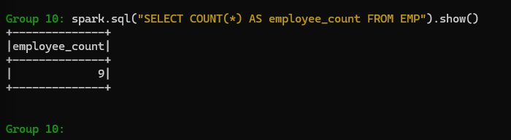
Calculate total salaries by states:
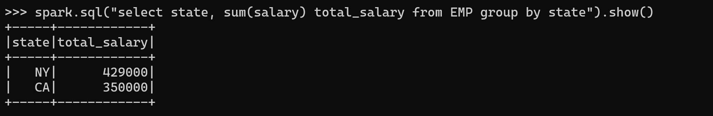
Calculate total salaries by states and departments:
?? spark.sql("SELECT state, SUM(salary) AS total_salary FROM EMP GROUP BY state").show()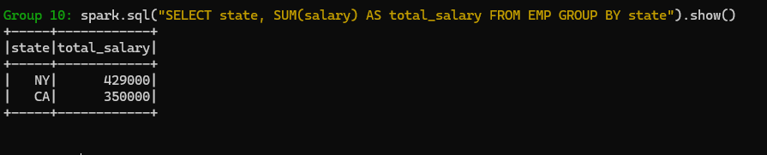

Redo exercise 2.6.3 using the IDE
Append the following line into the .bashrc file:
export PYTHONPATH="$SPARK_HOME/python:$SPARK_HOME/python/lib/py4j-0.10.9.7-src.zip"
Load the .bashrc file:
source .bashrc
Test:
python3 -c "import pyspark; print(pyspark.__version__)"

